Knife Detection Using YOLOv8s and YOLOv11s
name | id
Omar Mohammed Omar Abu Al Rub | 163333
Asem Omar Hmoud Al Hattamleh | 163633
Abdulraheem Musa Abdulraheem Alnatoor | 163222

Knife Detection Using YOLOv8s and YOLOv11s

Abstract
Our project develops and evaluates a real time knife detection system using single stage object detection . Two modern YOLO architectures YOLOv8s and YOLOv11s were fine tuned on a knife detection dataset with a single class that is knife . The training pipeline was implemented using the Ultralytics framework with transfer learning from pretrained weights , standard augmentations , and mixed precision training . Performance was assessed using standard object detection metrics like Precision , Recall , mAP@0.5 , and mAP@0.95. Both models achieved strong accuracy on the held out evaluation set , with YOLOv8s and YOLOv11s delivering comparable performance while differing in computational cost . Finally , the trained model was integrated into a Streamlit web interface to demonstrate practical deployment for interactive inference

1.Problem Statement
Knife detection is a safety oriented computer vision task aimed at identifying the presence of knives in images or video frames . The objective of our project is to train a robust detector that can localize knives with bounding boxes and achieve high accuracy under real world variability ( different lighting , backgrounds , scales , and occlusions ) , while remaining efficient enough for near real time inference

2.Research on Neural Networks and Architectures
Object detection has progressed from two stage detectors region proposal and classification to efficient one stage detectors direct prediction of bounding boxes and class probabilities . YOLO family detectors are widely used due to their balance of speed and accuracy
In our work
- YOLOv8s uses a lightweight architecture optimized for fast inference while maintaining accuracy
- YOLOv11s is a newer YOLO variant designed to improve efficiency and feature representation
From our models summarie
- YOLOv8s: ~11.14M parameters , ~28.6 GFLOPs ( imgsz=512 )
- YOLOv11s: ~9.43M parameters , ~21.5 GFLOPs ( imgsz=512 )

3.Models Development and Training

3.1 Dataset Selection and Exploration
A single class dataset was used with the class list defined in our data.yaml as
- Class names: knife
From the training logs we can see that
- Train set: 7,351 images ( 7,483 labeled boxes )
- Validation set: 918 images ( 937 labeled boxes )
Notes in our data : The Ultralytics loader reported some mixed detection segmentation annotation structure and therefore we used bounding boxes only ( segments were removed )
Table 1. Dataset summary
Split | Images | Instances ( boxes ) | Classes
Train | 7,351 | 7,483 | 1
Validation | 918 | 937 | 1
Test | 920 | 940 | 1

3.2.Training and Validation Process
We trained both models for 60 epochs with transfer learning from pretrained weights . Automatic Mixed Precision ( AMP ) was enabled
Table 2. Key training hyperparameters our best run
Item | YOLOv8s | YOLOv11s
Image size | 512 | 512
Batch size | 32 | 32
Epochs | 60 | 60
Augmentation | Enabled | Enabled
Optimizer | Auto selected AdamW (lr = 0.002, momentum = 0.9) | Auto selected AdamW (lr = 0.002, momentum = 0.9)
Early stop | 15 | 15
AMP | Enabled | Enabled
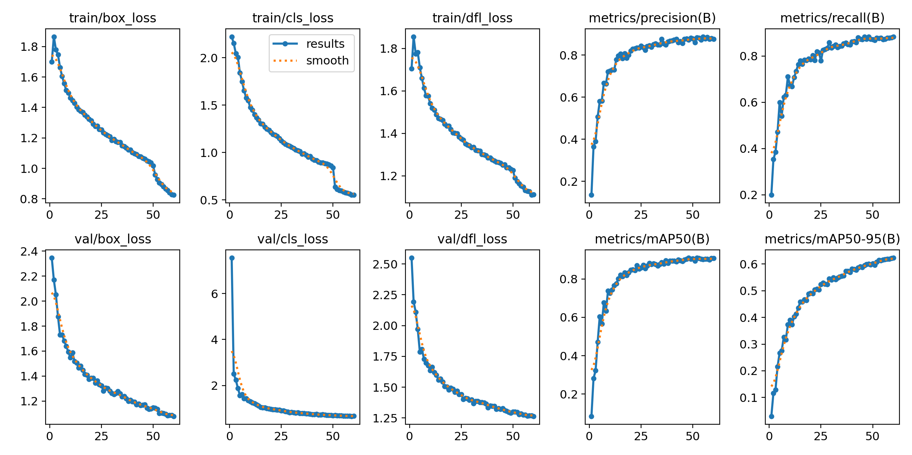
Figure 1. yolov8results.png

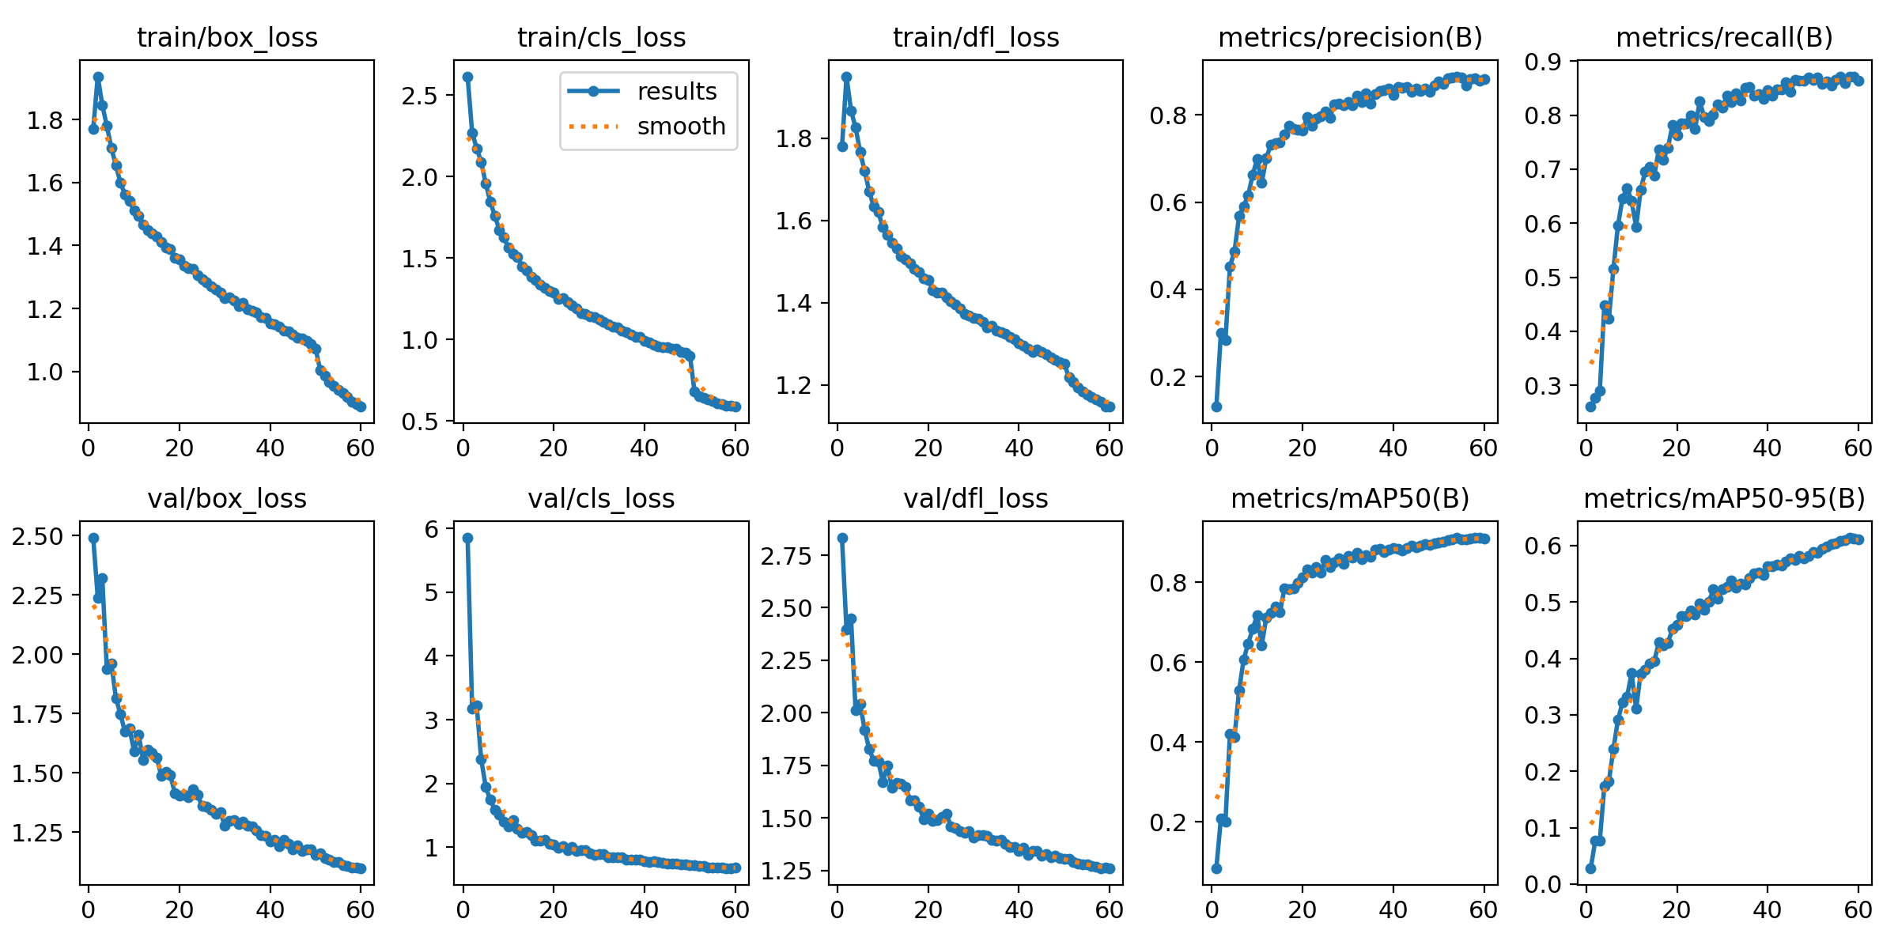
Figure 2. yolov11results.png

Table 3.Hyperparameter Search Results
Table 3 summarizes our validation performance for the hyperparameter configurations explored for each architecture . Each setting varies image resolution and batch size while keeping the learning rate request and augmentation enabled for consistency . our BEST row indicates the top performing configuration per model based on validation metrics
Table 3.Hyperparameter search results ( validation )
Architecture | Setting ID | imgsz | batch | lr0 | aug | Val P | Val R | Val mAP50 | Val mAP50-95
YOLOv8s | S1 | 512 | 16 | 0.01 | on | 0.846 | 0.866 | 0.893 | 0.612
YOLOv8s | S2 | 640 | 64 | 0.01 | on | 0.855 | 0.865 | 0.901 | 0.624
YOLOv8s | BEST | 512 | 32 | 0.01 | on | 0.864 | 0.877 | 0.910 | 0.631
YOLOv11s | S1 | 512 | 16 | 0.01 | on | 0.847 | 0.857 | 0.897 | 0.601
YOLOv11s | S2 | 640 | 64 | 0.01 | on | 0.857 | 0.867 | 0.907 | 0.613
YOLOv11s | BEST | 512 | 32 | 0.01 | on | 0.866 | 0.867 | 0.905 | 0.6163

4.Testing and Evaluation

4.1.Evaluation Metrics
Performance is reported using
- Precision (P) and Recall (R)
- mAP@0.5 ( IoU threshold 0.5 )
- mAP@0.95 ( average across IoU thresholds 0.5 to 0.95 )

4.2.Test Results (Best Models)
Table 4.Best model performance on testing set
Model | Test P | Test R | Test mAP50 | Test mAP50-95
YOLOv8s | 0.8784 | 0.8684 | 0.8987 | 0.6014
YOLOv11s | 0.8784 | 0.8630 | 0.8999 | 0.6100

4.3.Overfitting Discussion
From our learning curves ( Figures 1–2 ), validation metrics rise steadily and stabilize toward the end of training , indicating the training procedure achieves convergence without obvious late stage collapse in validation performance. Additionally the project used :
- data augmentation
- pretrained initialization
- and early stopping patience (15)
which collectively reduce overfitting risk.

4.4.Results Analysis and Model Choice
Both detectors achieve very similar test performance
- YOLOv11s shows slightly higher test mAP50-95 ( 0.6100 vs 0.6014 )
- while YOLOv8s shows slightly higher validation mAP50 in the best run ( 0.910 vs 0.905 )
From an efficiency standpoint , YOLOv11s is lighter in compute ( ~21.5 GFLOPs vs ~28.6 GFLOPs ) and has fewer parameters , which can be advantageous for deployment. Given the small accuracy differences , the final choice can reasonably be driven by deployment constraints ( latency and compute budget )
Dataset Size Ablation YOLOv11s
To analyze how dataset size affects performance , a dataset-size sweep was run on the
best model ( YOLOv11s ) , producing the following plots :
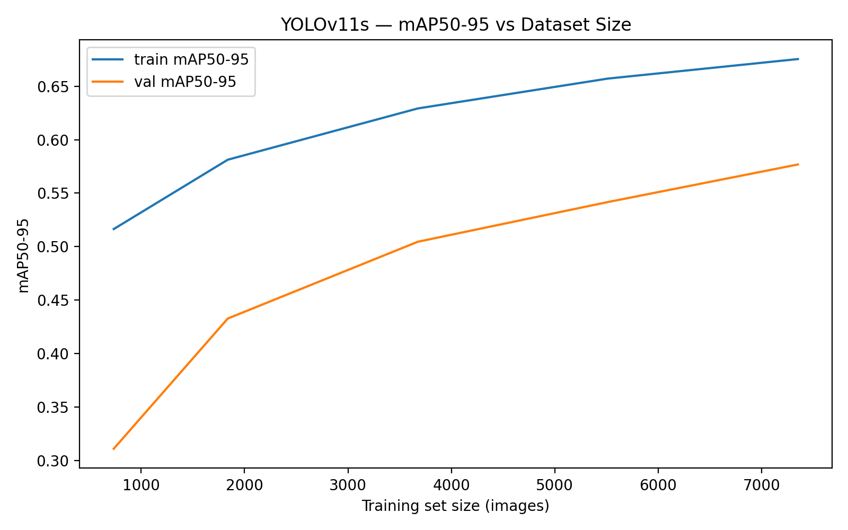
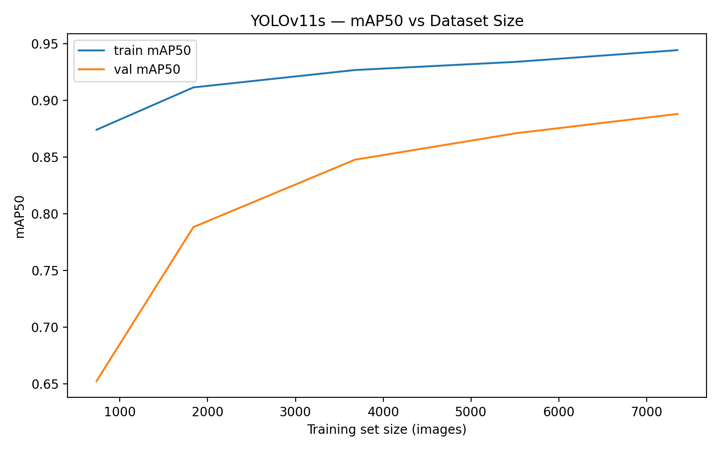

Figure 3&4 validation versus dataset size fraction.

Table 5. Dataset size sweep summary YOLOv11s
Train Fraction | Train Images | Val mAP50 | Val mAP50-95 | Train Time ( min )
0.10 | 735 | 0.750 | 0.452 | 7.58
0.25 | 1,837 | 0.805 | 0.503 | 12.98
0.50 | 3,675 | 0.845 | 0.545 | 22.17
0.75 | 5,513 | 0.872 | 0.564 | 32.71
1.00 | 7,351 | 0.888 | 0.577 | 42.83

Computational Requirements
All experiments were executed in the Kaggle environment with the NVIDIA Tesla T4 GPUs ( T4×2 ) available. Training runs were configured with standard Ultralytics settings and AMP enabled. For the best runs
- YOLOv8s training time : ~82.5 minutes ( 60 epochs , imgsz=512 , bs=32 )
- YOLOv11s training time : ~85.8 minutes ( 60 epochs , imgsz=512 , bs=32 )
Reported per-image inference speed from validation output:
- YOLOv8s: ~8.8 ms inference / image ( imgsz=512 )
- YOLOv11s: ~20.0 ms inference / image ( imgsz=512 )

4.5 Interface Development
A Streamlit interface was developed to demonstrate interactive knife detection.
Our deployed interface allows users to upload media and run inference using the trained YOLO model . The application overlays bounding boxes and confidence scores on detected knives and provides a practical demonstration of the end to end workflow from model training to real world usage .

4.6 Critical Evaluation
Key limitations and risks
- Dataset bias : performance may degrade in unseen environments ( different camera angles , lighting , motion blur , crowded scenes )
- Single class scope : the model only detects knives and may confuse visually similar objects ( tools , shiny utensils ) depending on training coverage
- Annotation format warning : mixed detect/segment artifacts were observed so the training proceeded using boxes only , which is appropriate for pure detection but should be cleaned in future iterations
- Operational thresholding : real world deployments typically require calibration of confidence thresholds to control false positives
Future improvements:
- add negative or hard negative examples
- expand to multi-class on the weapon categories
- evaluate on video sequences
- and perform robustness testing ( night , low res CCTV , occlusions )

